# 

# 

BCCE301 Project Proposal

# 

OSSIS Workflow integration development

# 

***Prepared by Zilin Li***

klk

# Home - Ara

Table of Contents

Project Details 3

Project Background: 3

Project Goal 3

Expected Outcomes 3

Quality Assurance 4

Project Hierarchy: 5

Reporting Procedure 6

Project Benefits 6

Student Skills Involved & Benefits to Learning 7

Resources Require 8

Project Risks 9

Project Parameters 10

Industry Project Dates 10

Cost (Hours) 10

Meetings 10

Academic Portion Time Allowance 11

Burn Down Chart 11

Project Plan 12

Project Timeline: 12

Project Phase: 12

# Project Details

**Project Name:** OSSIS Workflow integration development

**Enterprise Involved:** OSSIS Limited

**Enterprise Website:** [www.ossis.com](http://www.ossis.com)

# Project Background:

OSSIS is a medical device company that specialises in designing custom implant devices primarily for custom hip implants. It is NZ owned and has been operating in the industry for 15 years. OSSIS is the only custom implant provider in Australasia. Because the company has grown substantially over the past few years, the current workflow system no longer keeps pace with the increased demand for OSSIS products.

Currently, OSSIS has five separate systems for recording patient data that operate independently and cannot be linked to each other. There are a lot of manual and repetitive inputs in the current workflow. OSSIS wanted to find a way to integrate the current system and reduce the redundancy of multiple entries into various systems.

# Project Goal

* Research and develop the feasibility scheme of existing workflow system integration.
* Develop a program that exports essential bits of information from the OSSIS primary customer database (Workflow Max) and automatically imports it into the collaboration workspace (Monday.com).
* Improve work efficiency and reduce manual operation

# Expected Outcomes

## Industry Outcomes

* Investigate the feasibility of integration between Workflow Max and Monday.com.
* Develop an office application that synchronizes essential information from the Workflow Max to Monday.com (Export Job details based on the Job Number specified by the user and import the data into the Monday.com system).
* Achieve one-key synchronization of working status.
* Testing

## Academic Outcomes

* Project proposal report
* Project timeline
* Risk assessment and management plan
* Quality assurance
* Mid project report
* Burn-down chart
* Weekly status updates
* Methodology essay
* Final project report & poster
* Panel Presentation

# Quality Assurance

|  |  |  |
| --- | --- | --- |
| **Deliverables** | **QA Measures** | **Signoff** |
| **OSSIS Workflow integration development** | * Weekly meetings with academic supervisor to ensure the quality of progress. * Weekly progress reports will be provided to academic supervisor. * Weekly meeting with industry supervisor or email to report project progress. * Communicate timely and record feedback. | IS & AS |
| **Risk Management Plan** | * Develop a project risk management plan and approve by academic supervisor and industry supervisor * Evaluate project risks and formulate corresponding risk countermeasures promptly * Review the risk plan regularly and change the risk plan according to the specific situation * Report project risk status to academic supervisor & industry supervisor in time. | IS & AS |
| **Quality Assurance Programme** | * Develop a quality assurance plan and approve by academic supervisor and industry supervisor. * Review project quality promptly throughout the project. * Mid-term project review and final project review. | IS & AS |
| **Methodology Report** | * Report the progress of the Methodology Report to academic supervisor weekly * Signoff from academic supervisor and course supervisor | AS&CS |
| **Project Half-Way Report & Final Report** | * Report the progress of methodology report to academic supervisor weekly * Signoff from academic supervisor and industry supervisor | AS&IS |
| **Project Timeline** | * Updated throughout the project * Lists phases and their estimated times * Lists tasks * Conduct weekly self - review of progress |  |

# Project Hierarchy:

### Industry Supervisor

Name: Jessica Urquhart

Position Held: Operations Manager

Postal Address: 7/2 Barry Hogan Place, Christchurch 8041

Email: Jessica@ossis.com

Telephone: 22 327 9705

Academic Supervisor

Name: Amit Sarkar

Position Held: Lecturer, Department of Computing

Postal Address: 130 Madras Street, Christchurch 8011

Email: amit.sarkar@ara.ac.nz

Telephone: 03 940 8495

### Academic Course Coordinator

Name: Dr David Weir

Position Held: Lecturer, Department of Computing

Postal Address: 130 Madras Street, Christchurch 8011

Email: david.weir@ara.ac.nz

Telephone: 03 940 8324

### Student

Name: Zilin Li

Position Held: Student, Department of Computing

Postal Address: 7 Abbotts Place, Christchurch 8042

Email: lynnlee829@gmail.com

Telephone: 22 543 3166

|  |
| --- |
| Reporting Procedure Academic Supervisor   * Weekly Meeting in Amit’s office at Ara 12 pm on Tuesday. * Written weekly status reports, these will be emailed on the previous Sunday. * Email questions or organise a meeting as required.   Industry Supervisor   * Weekly Meeting with industry supervisor in OSSIS office from 9 am-12:30 pm on Friday. * Email questions or organise a meeting as required. |

# Project Benefits

Currently, OSSIS mainly uses Workflow Max for managing the customer database and Monday.com for managing worker processes. Due to the independence of the two systems, OSSIS needs to manually enter customer information into the two systems in the workflow. A large number of manual operations not only affect work efficiency but also increase the possibility of operation errors.

This project will bring the following benefits to the company:

* Through this project, the data connection between the two systems can be established, thus reducing repetitive manual input, and improving work efficiency. Workflow Max is the primary software for managing customer data, and this project implements features that allow Monday.com to get data directly from Workflow Max without having to re-enter it.
* Reducing the process of repeated input will greatly reduce the error rate caused by input.
* Exploring the availability of the Workflow Max API provides a good foundation for integrating other possible applications with Workflow Max later.

As a student, the benefits of this program are as follows:

* In this project, I can have the opportunity to learn and practice how to effectively communicate with customers, define customer needs and obtain customer feedback.
* Learn how to translate customer requirements into executable IT project development requirements.
* Learn how to implement project quality assurance, risk control and management, and project time management in IT development projects.
* Through the development work in the real world, I could apply the IT technology I have learned in practice and accumulate relevant work experience.
* Through the analysis and learning of two working system API, understand how to use the third-party API interface.
* By writing system integration software, accumulate practical experience of integrating third-party applications.

# Student Skills Involved & Benefits to Learning

To successfully complete this project, these general skills will be needed of me:

**Project Management**

This project involves a complete software development process. The whole project process includes obtaining and analysing customer requirements, researching and discussing feasibility solutions, software function design, development language selection, software safety analysis, software development and testing. To complete the above process within 288 hours requires me to strictly control and manage the project according to what I have learned in the ICT project management course. Including project quality management, task management, time management, risk management and stakeholder communication management.

**Business analysis**

Learn and study third-party software according to user requirements and analyse the project risks and feasibility through the obtained information.

**Software development related expertise**

* API interface
* Database management
* The front-end development
* The backend development
* Software functional testing
* Code versioning

Also, the following specialist skills will be needed of me:

* Be able to learn and adapt to a new language and software in a short time
* Be able to communicate well with clients and have good writing skills
* Ability to work in a team, but also the ability to develop independently
* Have good time management ability. Able to complete academic tasks while focusing on project development
* Be able to timely find and control project risks, and make timely response measures
* Ability to write high-quality code for later software upgrades and maintenance

# Resources Require

* Access to Workflow Max
* Access to Monday.com
* Access to OSSIS email
* Access to Miro.com
* Computer equipment used for software development
* Email for communication, video conferencing software, Microsoft Office Suite

# Project Risks

These are the risks I have identified that could affect my progress of the industry project. The chart will be updated during the project.

|  |  |  |  |  |  |  |  |  |
| --- | --- | --- | --- | --- | --- | --- | --- | --- |
|  | **Risk Statement** | | **Probability**  **(%)** | **Impact**  **(1-10)** | **Exposure** | **Mitigation** | **Contingency** | **Triggers** |
| **#** | **Condition** | **Consequence** |
| 1 | The third-party software (WorkflowMax&Monday.com) API cannot meet the requirements of this project. | The project could not meet the user's requirements, so we need to communicate and seek other solutions. | 50% | 10 | 5 | Complete the feasibility analysis of the third-party software API as soon as possible at the beginning of the project. | Communicate with customers in a timely manner to provide alternatives that can meet customer needs. | Because of the high dependence of users on third-party software at present, this risk exists in the early stage of the project. |
| 2 | Third-party software API interfaces are unstable or overly restrictive to use. | Increase the difficulty of system integration. This results in a lack of stability in the software being developed. | 50% | 10 | 5 | Send an email to a third party for technical support. | Communicate with customers in a timely manner to provide alternatives that can meet customer needs. | Because of the high dependence of users on third-party software at present, this risk exists in the early stage of the project. |
| 3 | Unable to obtain technical support for third-party software or technical support response time is too long. | Seriously affect the project schedule or the project cannot be completed. | 40% | 9 | 3.6 | Multiple approaches to learning and research. Through every possible way to get contact with the third-party software company. | Communicate with customers in a timely manner to provide alternatives that can meet customer needs. | Because of the high dependence of users on third-party software at present, this risk exists in the early stage of the project. |
| 4 | Project timeout | Project execution time far exceeds the 288 hours required for the course, resulting in a significant impact on course scores. | 50% | 2 | 1 | Monitor and re-evaluate milestones weekly | Focus on milestones that can be completed in time and stop before your score drops. | The project lacks technical support and spends too much time on research and study. |
| 5 | Lockdown because of COVID-19 | Lost in face-to-face communication and academic supervisor and industry supervisor increased the difficulty of communication. | 80% | 2 | 1.6 | Pay close attention to the epidemic information at any time and prepare for the lockdown in advance. | Developed using my own computer equipment, I can work from home during the lockdown. Communicate by video conferencing (ZOOM), email, etc. | The situation of COVID-19 is getting worse. |
| 6 | New code is faulty or missing and needs to be restored to the previous version | All and part of the code needs to be redone | 80% | 2 | 1.6 | Maintain good code version management and upload the code to the version management software timely. | Restore the last version of the software | New code is faulty, a file is corrupted, or the computer is lost. |
| 7 | Sickness | The time I cannot spend working on the project increases the chance of running out of time | 5% | 4 | 0.2 | Set aside extra time in your schedule | In case of serious illness, obtain a medical certificate and contact AS&IS promptly. | Not feeling well enough to be able to do more work on the project. |

# Project Parameters

## Industry Project Dates

Start Date: Monday 24th of August 2020

Intended End Date: Friday 15th of November 2020

## Cost (Hours)

Industry Hours Hours provided to produce the industry project 288 hours

Academic Hours Hours to spend on the academic part of the course 162 hours

Total Hours 450 hours

## Meetings

### Industry Supervisor Meeting every Friday from 9 am-12:30 pm

Academic Supervisor Meeting every Tuesday from 12 pm – 1 pm

Course Meeting every Thursday from 4pm - 5pm

## Industry Project Timetable

These charts show my working schedule for both industry and academic hours for the duration of the project.

|  |  |  |  |  |  |
| --- | --- | --- | --- | --- | --- |
| **Industry Hours** | | | | | |
| **Monday** | **Tuesday** | **Wednesday** | **Thursday** | **Friday** | **Total** |
| 9am-2pm | 9am-2pm | 9am-2pm | 9am-2pm | 9am-1pm |
| TBA | TBA | TBA | TBA | Industry Supervisor weekly meeting |
| **5 hours** | **5 hours** | **5 hours** | **5 hours** | **4 hours** | **24 hours** |

|  |  |  |  |  |  |
| --- | --- | --- | --- | --- | --- |
| **Academic Hours** | | | | | |
| **Monday** | **Tuesday** | **Wednesday** | **Thursday** | **Friday** | **Total** |
| 7pm-9pm | 7 pm - 9 pm | 8 pm - 10 pm | 7 pm - 9 pm | 7 pm - 10 pm |
| TBA | Academic supervisor meeting 12 pm | TBA | Course meeting at 4 pm | TBA |
| **2 hours** | **2 hours** | **2 hours** | **2 hours** | **3 hours** | **11 hours** |

## Academic Portion Time Allowance

The recommended academic hours for this course are 162 hours, of which 18 hours will be spent in weekly course meetings and academic supervisor meetings. I allocated the remaining 144 hours reasonably according to the focus of work and the proportion of task assignment in each stage of the project.

Since the project starts in the fifth week of the semester, there are 15 weeks (including two weeks of vacation) from the beginning of the project to the presentation of the report, and the average working time is 10 hours per week.

## Burn Down Chart

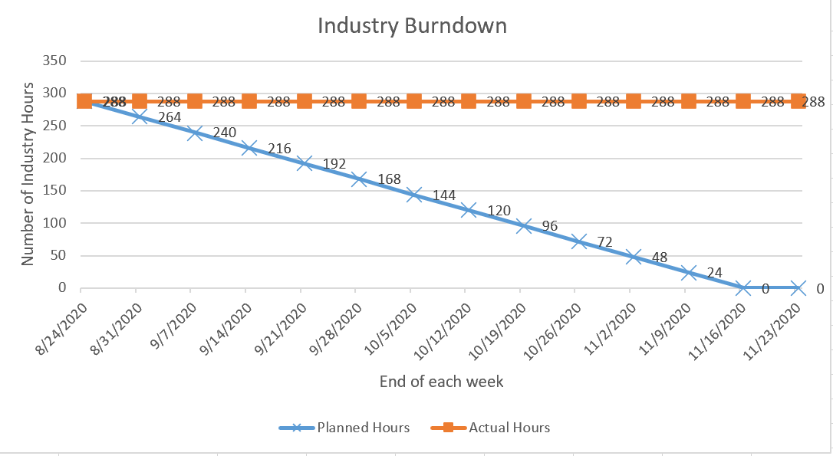

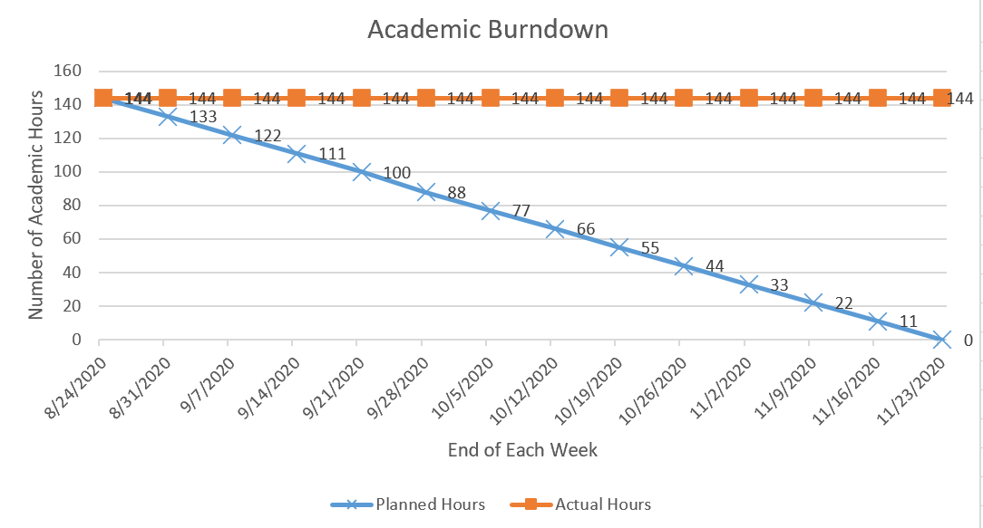

# Project Plan

## Project Timeline:

**Project Start Date:**

Week of 24th of August

**Project End Date:**

Week of 16th of November

**Project Length:**

13 weeks (288 hours, Includes term holidays)

**Project average hours per week:**

24 hours Industry [I] – 11 hours Academic [A]

## Project Phase:

**Phase One:** **One week** (24 I hrs. – 11 A hrs.)

* Collect user requirements (I)
* Discuss project feasibility with users (I)
* Project Proposal (I &A)

**Phase Two:**  **Three weeks** (72 I hrs. – 33 A hrs.)

* Research and learn Workflow Max API (I)
* Test Workflow Max API (I)
* Research and learn the Monday.com API (I)
* Test the Monday.com API (I)
* Research and evaluate the possibility of connecting and integrating data from the two systems (I)
* Halfway Project Report (I &A)

**Phase Three** **Six weeks** (144 I hrs. – 67A hrs.)

* Project program Development (I)
* Project methodology and practice (A)

**Phase Four** **Three weeks** (48 I hrs. – 33 A hrs.)

* + Program Testing (I)
  + Project Review (I &A)
  + Preparation of project Final Report (I &A)
  + Poster (I &A)
  + Panel presentation (I &A)